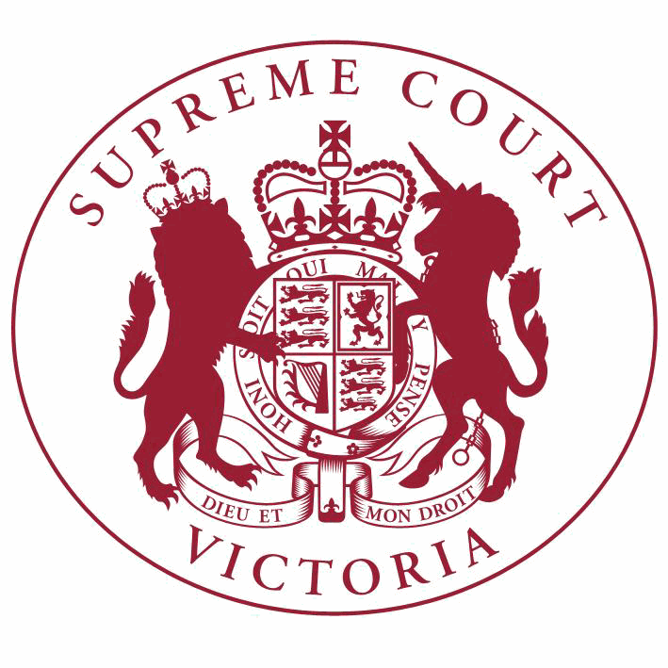

Supreme Court List for Thursday 12 October 2017

COURT OF APPEAL  courtrooms are located at: | TRIAL DIVISION  courtrooms are located at:
459 Lonsdale St. Melbourne | 210 William St. Old High Court 436 Lonsdale St. WCJC Melbourne Ground Floor Melbourne 223 William St.  450 Little Bourke St. Melbourne  Melbourne

NOTICES TO THE PROFESSION AND OTHER SUPREME COURT USERS

A Welcome Ceremony for the Chief Justice will be held today at 9:15am in the Banco Court. Counsel are requested to robe.
--------------------------------------------------------

Full Court

The Chief Justice, The President, Justice Kidd

Court 1, Ground Floor
210 William Street, Melb.

9:15 Welcome Ceremony

Court of Appeal

Criminal Division

Justice Priest
Green Court, Ground Floor
459 Lonsdale Street, Melb.

10:30 S APCR 2017 0095
Quyen Van Hoang

v. R
Application for Leave to
Appeal (oral hearing)

11:30 S APCR 2017 0071
Toby Quinn (a pseudonym)

v. R
Application for Leave to
Appeal (oral hearing)

Trial Division

Criminal Division Justice Hollingworth Court 11, Ground Floor
210 William Street, Melb.

11:00
S CR 2017 0242
In the matter of an application by I
Application under the
Surveillance Devices Act

Trial Division - Continued

Criminal Division- Continued

11:00
S CR 2017 0242
In the matter of an application by I
Application under the
Surveillance Devices Act

Justice Lasry
Court 4, Ground Floor
210 William Street, Melb.

10:30 S CR 2017 0085
R

v. Katia PYLIOTIS
Part Heard

Justice Macaulay
Court 3, Ground Floor
210 William Street, Melb.

9:30 S CR 2014 0047
R

v. Christian BOILLOT
Directions Hearing

9:30 S CR 2014 0048
R

v. Myles Andrew CURTIS
Directions Hearing

9:30 S CR 2014 0049
R

v. John LECKENBY
Directions Hearing

9:30 S CR 2014 0058
R

v. Barry Thomas BRADY
Directions Hearing

Justice Croucher
Court 2, Ground Floor
210 William Street, Melb.

10:30 S CR 2016 0033
R

Common Law Division

Justice Macaulay
Court 3, Ground Floor
210 William Street, Melb.

v. Omer CICEKDAG
For Plea

Judicial Review and Appeals List

12:00 S CI 2017 02468
Director of Public Prosecutions
(on behalf of Robert Baker)

v. Jason Tupper
Application

Justice Zammit
Court 13, First Floor
210 William Street, Melb.

10:30
1 S CI 2014 04993
Ian Huntington

v. The Kew Golf Club & Ors.
Trial

Trial Division - Continued

Common Law Division- Continued

Justice Keogh
Court 5, Ground Floor
210 William Street, Melb.

10:30 S CI 2015 06504
Ryan Reaks (Who sues by his Litigation Guardian Neil William Reaks)
Judicial Registrar Englefield
Room 1, Mediation Centre, Sixth Floor
436 Lonsdale Street, Melb.

v. Roy Cecil McCarthy
Trial

10:30 S CI 2016 04265
Elizabeth Gower

Practice Court (Common Law)
Justice McDonald
Court 10, Ground Floor
210 William Street, Melb.

v. Candice Danee MacDonald (also known as Candice Danee Gower ) (Who is sued as an executor of the Will of the abovenamed deceased) & Ors.
For Mediation

10.30 Practice Court Business

URGENT APPLICATIONS Contact the Associate to the Practice Court Judge (AFTER HOURS ONLY) on
0412 251 757 or 0419 303 981
During business hours, contact the Practice Court Coordinator on 9603 9288.

Justice Garde
Court 6, First Floor
210 William Street, Melb.

2:15
S PRB 2016 05959
In the matter of the Estate of Christa Renate Hobbs
Judgment for Costs

Commercial Court

Justice Vickery
Court 12, Ground Floor
210 William Street, Melb.

10:30 S CI 2015 04098
National Australia Bank Limited
(ABN 12 004 044 937)

v. Anandavalli Ganesh & Ors.
Application

Justice Elliott
Court 9, First Floor
210 William Street, Melb.

Trial Division - Continued

Commercial Court- Continued

10:30 S ECI 2015 00412
Paul De Lutis

v. DeGroup Pty Ltd (ACN 006 181 906)
& Ors.

For Mention

10:30 S ECI 2015 00435
Paul De Lutis

v. Colin De Lutis & Ors.
For Mention

11:00 S ECI 2014 00146
Cargill Australia Limited (ACN
004 684 173)

v. Viterra Malt Pty Ltd (ACN 096 519
658) & Ors.
Application

Justice Riordan Court 1, Ground Floor Old High Court
450 Little Bourke Street, Melb.

Technology, Engineering & Construction List

10:30 S ECI 2017 00115
Hacer Group Pty Ltd

v. Geotech Pty Ltd & Ors.
Trial

Justice Kennedy
Court 7B, Ground Floor
210 William Street, Melb.

Corporations List

10:00 S CI 2016 01759
Donkey Wheel Limited (ACN 109
045 650) Associate Justice Randall Court 3, Ground Floor
436 Lonsdale Street, Melb.

v. Mark Jonathan Irving Brunner
Appeal

Corporations List

10:30
1 S CI 2017 04048
Ganeson-Eckhart Pty Ltd (ACN
612 029 160)

v. Gordagen Pharmaceuticals Pty Ltd
(ACN 161 094 382)
Application

Judicial Registrar Matthews
Room 1, Mediation Centre, Sixth Floor
436 Lonsdale Street, Melb.

Corporations List

10:30 S ECI 2017 00054
Brent Leigh Morgan (as Liquidator of KEON MANOR PTY LTD (in Liquidation) ACN
052 427 371) & Ors.

Commercial Court Duty Judge

v. Shaun Edward Rodgers
For Mediation

Justice Elliott
Court 9, First Floor
210 William Street, Melb.

10:30 S ECI 2016 01203
Brent Leigh Morgan (in his capacity as Official Liquidator of Mitchco Excavations Pty Ltd (In Liquidation) (ACN 113 109 694)
& Ors.

v. Colin Leslie Mitchell
Application

URGENT APPLICATIONS During business hours, contact the Commercial Court Registry on 9603 4105.
Contact the Associate to the Commercial Court Duty Judge (AFTER HOURS ONLY) on
0439 153 522.

Costs Court

Associate Justice Wood
Court 8, Fourth Floor
436 Lonsdale Street, Melb.

11:00
1 S CI 2017 00485
Jadbas Pty Ltd trading as Grace
Costs Consultants

v. Bruce Pippett
Taxation of Costs

Associate Judges Associate Justice Daly Court 4, Ground Floor
436 Lonsdale Street, Melb.

11:30
1 S CI 2017 03607
Sunder Babu Etta

v. Ron Pearce & Ors.
First Directions

2:15
2 S CI 2017 00891
Michela Joy Burke

v. Ash Sounds Pty Ltd trading as The
Falls Music and Arts Festival (ABN
67 160 019 152)
Application

Associate Justice Gardiner
Court 5, Ground Floor
436 Lonsdale Street, Melb.

10:30
1 S ECI 2016 01256
Molonglo Group (Australia) Pty
Ltd (ACN 109 342 547)

v. Peter Joseph Cahill & Ors.
Application

Pre-Trial Conferences Deputy Prothonotary Clark Conference Room, Fourth Floor
436 Lonsdale Street, Melb.

10:00 S CI 2017 01703
Bryan David Chilver

v. Director of Housing & Ors.
Pre-Trial Conference

